Note: This document is “view only”. Please create a copy of this document and save it to your drive.

**SOP- Setting up a Client Channel- Systems Vault**

**PREREQUISITES**

[Project Management Tool- Teamwork](http://sarahnoked.com/teamwork)

[Master: Guidelines- Naming Conventions- Systems Vault](https://docs.google.com/document/d/1IsYwJoykfoADN6hC3jGEgms5vz92vpVEAHWlxIMMJW8/edit?usp=sharing)

[SOP MASTER Client Onboarding- Systems Vault](https://docs.google.com/document/d/1h15rYHmTzGFdfzso_DxqyYtqkFcpNlM8DWo4YLwYBn4/edit?usp=sharing)

**PURPOSE**

To set up a channel for our team to communicate in real time regarding any client issues

**POLICY:**

This occurs on an as-needed basis. Check the name of the channel follows naming conventions: [SN Guidelines: Naming Conventions](https://docs.google.com/document/d/1IsYwJoykfoADN6hC3jGEgms5vz92vpVEAHWlxIMMJW8/edit?usp=sharing)

**PARTY**

Virtual Assistant

**PROPERTY**

Online Business Manager

**PROCESS:**

Part 1: Create a channel and add main team members

Part 2: Create a channel between yourself and another team member

**PROCEDURES**

**Part 1: Create a channel and add main team members**

1. Navigate to the to the right of the Teamwork Chat logo
2. Click on ‘Create Channel

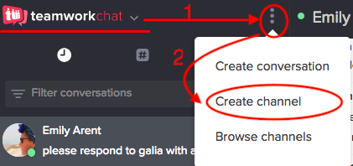

1. Name the channel according to [SN Guidelines: Naming Conventions](https://docs.google.com/document/d/1IsYwJoykfoADN6hC3jGEgms5vz92vpVEAHWlxIMMJW8/edit?usp=sharing) and add team members.
   1. The drop down menu next to names will allow you to see all available members to add

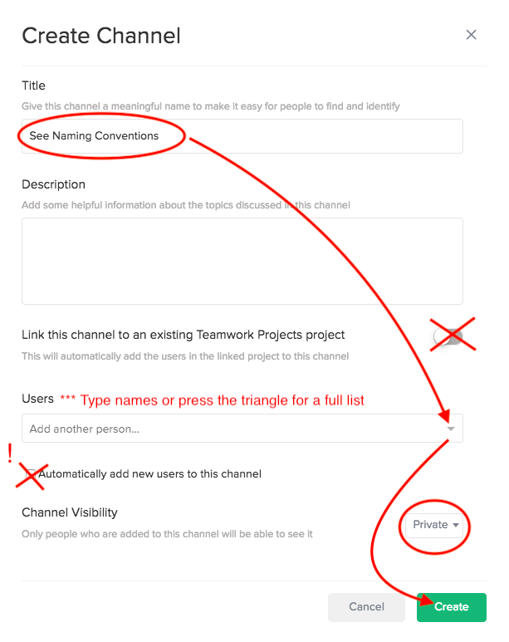

1. Check who is in the group by clicking on the icon and see who is the creator, admins, and members.
2. Send a nice message (does not have to be exact) “Hi everyone, this chat is designated to (Person/company name), where we will be discussing tasks, ideas, and growing the business!”

**Part 2: Create a channel between yourself and another team member**

1. Next to the Teamworkchat logo click the three dots and select ‘create conversation’

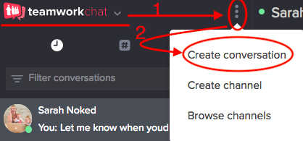

1. In the next window type “@” to begin seeing who is available to join a new conversation

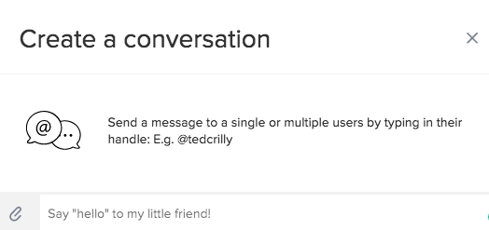

1. Write your first message (note: use @firstname to make sure they receive a notification)

**Created by:**

**Department:** Delivery

**Date:**

**Revised:**

**Revised by:**